Insurance Fraud Detection Using Machine Learning
Model Building:
1. Decision Tree Model
1.1 Overview
A decision tree is a non-parametric supervised learning method used for classification and regression. It models decisions and their possible consequences as a tree-like structure. Internal nodes represent tests on features, branches represent outcomes of the test, and leaf nodes represent class labels (in classification). Decision trees are intuitive and easy to interpret, making them a popular choice for exploratory modeling.
1.2 How It Works
The tree is built by recursively partitioning the feature space into regions that are as homogeneous as possible with respect to the target variable. At each node, the algorithm selects the feature and split point that best separates the classes according to a chosen impurity measure. Common impurity measures include:
- Gini Impurity: Measures the probability of misclassifying a randomly chosen element if it were randomly labeled according to the class distribution in the node. It is computed as:
$$Gini=1-\sum_{i=1}^{C}{p_{i}^{2}}$$
where $p_{i}$ is the proportion of class $i$ samples in the node. Lower Gini indicates purer nodes.
- Entropy: Based on information theory, it measures the disorder or uncertainty. It is defined as:
$$Entropy=-\sum_{i=1}^{C}{p_{i}}{log⁡}_{2}(p_{i})$$
The goal is to maximize information gain, i.e., the reduction in entropy after splitting.
The algorithm evaluates all possible splits for each feature and selects the one that maximizes the impurity reduction (or gain). This process continues recursively until a stopping criterion is met (e.g., maximum depth, minimum samples per leaf, or no further gain).
1.3 Advantages
- Easy to understand and visualize.
- Handles both numerical and categorical data (though encoding is needed for scikit-learn).
- Non-parametric, so no assumptions about data distribution.
- Can capture non-linear relationships.
1.4 Disadvantages
- Prone to overfitting, especially with deep trees. This can be mitigated by pruning (limiting depth, setting minimum samples for splits) or using ensemble methods.
- Sensitive to small variations in data; a different split can yield a completely different tree.
- May create biased trees if some classes dominate (handled via class weighting or resampling).
1.5 Application in Fraud Detection
Decision trees can reveal which features (e.g., claim amount, incident type) are most predictive of fraud. However, due to overfitting, they are often used as base learners in ensembles like random forests.
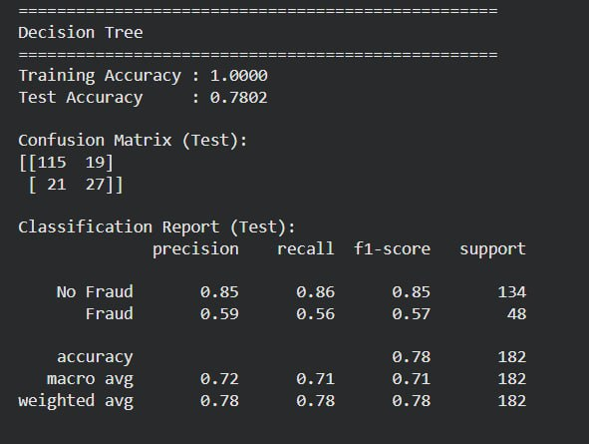

2. Random Forest Model
2.1 Overview
Random Forest is an ensemble learning method that constructs a multitude of decision trees at training time and outputs the class that is the mode of the classes (classification) of individual trees. It combines the concepts of bagging (bootstrap aggregating) and random feature selection to create a diverse set of uncorrelated trees, thereby improving generalization and reducing overfitting.
2.2 How It Works
- Bootstrap Sampling: For each tree, a random sample of the training data is drawn with replacement (bootstrap sample). Typically, the sample size equals the original dataset, but about one-third of instances are left out (out-of-bag samples) and can be used for internal validation.
- Random Feature Selection: At each node split, only a random subset of features is considered (instead of all features). This decorrelates the trees, as even strong predictors cannot dominate all splits.
- Aggregation: For classification, each tree votes for a class, and the majority vote determines the final prediction. The ensemble reduces variance without increasing bias.
2.3 Key Parameters
- n_estimators: Number of trees in the forest. More trees generally improve performance but increase computational cost.
- max_depth: Maximum depth of each tree (or None for unlimited growth).
- min_samples_split: Minimum number of samples required to split an internal node.
- min_samples_leaf: Minimum samples required at a leaf node.
- max_features: Size of the random subset of features to consider at each split (often set to sqrt(p) for classification, where p is total features).
2.4 Advantages
- Highly accurate and robust to overfitting (due to averaging).
- Handles high-dimensional data well.
- Provides feature importance scores based on how much each feature reduces impurity across all trees.
- Can handle missing data and maintains accuracy even when a large proportion of data is missing.
2.5 Disadvantages
- Less interpretable than a single decision tree.
- Requires more computational resources and memory.
- May overfit with very noisy datasets if not properly tuned.
2.6 Application in Fraud Detection
Random forests are widely used in fraud detection because they can capture complex interactions and are robust to class imbalance (when combined with class weighting or balanced sampling). Feature importance helps identify key fraud indicators.
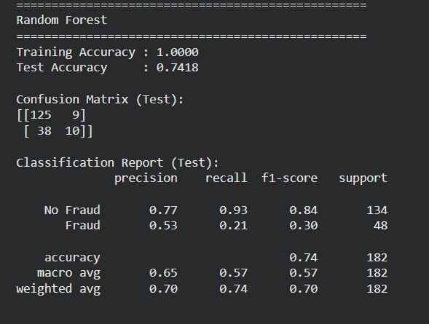

3. K-Nearest Neighbors (KNN) Model
3.1 Overview
K-Nearest Neighbors is a simple, instance-based learning algorithm that classifies a new sample based on the majority class among its k closest neighbors in the feature space. It is a non-parametric, lazy learner because it does not build an explicit model during training; instead, it memorizes the training data and performs computation at prediction time.
3.2 How It Works
- Distance Metric: The closeness between points is measured using a distance function, commonly Euclidean distance:
$$d(x,y)=\sqrt{\sum_{i=1}^{n}{(}x_{i}-y_{i})^{2}}$$
Other metrics like Manhattan or Minkowski can also be used.
- Choosing k: The number of neighbors k is a hyperparameter. A small k makes the model sensitive to noise, while a large k smooths out decisions but may overlook local patterns. Typically, odd values are chosen to avoid ties.
- Voting: For classification, the predicted class is the mode of the classes of the k nearest neighbors. Optionally, distances can be weighted so that closer neighbors have more influence.
- Prediction: For a new instance, distances to all training points are computed, the k smallest are selected, and a majority vote determines the class.
3.3 Importance of Feature Scaling
Since KNN relies on distance calculations, features with larger scales will dominate the distance metric. Therefore, scaling (e.g., StandardScaler) is essential to ensure all features contribute equally.
3.4 Advantages
- Simple to understand and implement.
- No training phase (lazy learning), making it fast to "train."
- Naturally handles multi-class cases.
- Can adapt to complex decision boundaries if data is dense.
3.5 Disadvantages
- Prediction can be slow for large datasets because distances to all training points must be computed.
- Sensitive to irrelevant features and noise.
- Curse of dimensionality: performance degrades as the number of features increases, because distances become less meaningful in high-dimensional spaces.
- Requires careful selection of k and distance metric.
3.6 Application in Fraud Detection
KNN can be effective when the fraud patterns are localized in the feature space (e.g., similar claims tend to be fraudulent). However, due to the curse of dimensionality and the need for scaling, it may not perform as well as ensemble methods on high-dimensional data.
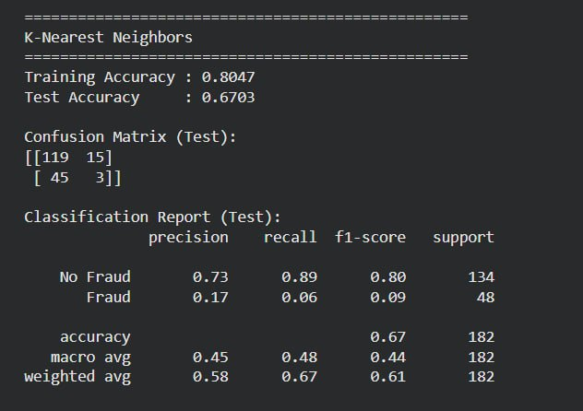

4. Logistic Regression Model
4.1 Overview
Despite its name, logistic regression is a linear model for binary classification. It models the probability that an instance belongs to a particular class using the logistic (sigmoid) function. It is widely used due to its simplicity, interpretability, and probabilistic output.
4.2 How It Works
- Linear Combination: First, a linear combination of the input features is computed:
$$z=β_{0}+β_{1}x_{1}+β_{2}x_{2}+⋯+β_{n}x_{n}$$
where $β$ are the coefficients (weights) learned from data.
- Sigmoid Function: The linear output $z$ is passed through the sigmoid function to map it to a probability between 0 and 1:
$$P(y=1∣X)=\frac{1}{1+e^{-z}}$$
- Decision Boundary: If $P(y=1)≥0.5$, the instance is classified as class 1; otherwise, class 0. This corresponds to a linear decision boundary in the feature space.
- Training: The coefficients are estimated by maximizing the likelihood of the observed data (maximum likelihood estimation). This is typically done using iterative optimization algorithms like gradient descent or Newton's method. The loss function minimized is the log-loss (binary cross-entropy):
$$J(β)=-\frac{1}{m}\sum_{i=1}^{m}{[}y^{\left(i\right)}log⁡(p^{\left(i\right)})+(1-y^{\left(i\right)})log⁡(1-p^{\left(i\right)})]$$
4.3 Interpretation of Coefficients
The exponentiated coefficient $e^{β_{j}}$ represents the odds ratio for a one-unit increase in feature $x_{j}$, holding other features constant. Positive coefficients increase the log-odds of the positive class, while negative coefficients decrease it.
4.4 Assumptions
- Linear relationship between log-odds and features.
- Independence of errors (no multicollinearity).
- No or little multicollinearity among features (though regularization can help).
- Large sample size for stable estimates.
4.5 Regularization
To prevent overfitting and handle multicollinearity, regularization terms can be added:
- L1 (Lasso): Adds penalty proportional to absolute value of coefficients, encouraging sparsity.
- L2 (Ridge): Adds penalty proportional to square of coefficients, shrinking coefficients but not to zero.
- Elastic Net: Combination of L1 and L2.
In scikit-learn, the LogisticRegression class with penalty='l2' is commonly used.
4.6 Advantages
- Provides probabilistic predictions.
- Highly interpretable (coefficients give insight into feature importance).
- Efficient to train and fast for prediction.
- Works well when the relationship between features and log-odds is approximately linear.
4.7 Disadvantages
- Assumes linear decision boundary, which may not capture complex patterns.
- Sensitive to outliers.
- Can underfit if true relationship is highly non-linear.
4.8 Application in Fraud Detection
Logistic regression serves as a strong baseline model. It can quickly identify which features are most influential (e.g., claim amount, policy age) and provide a probability score that can be thresholded to flag suspicious claims.
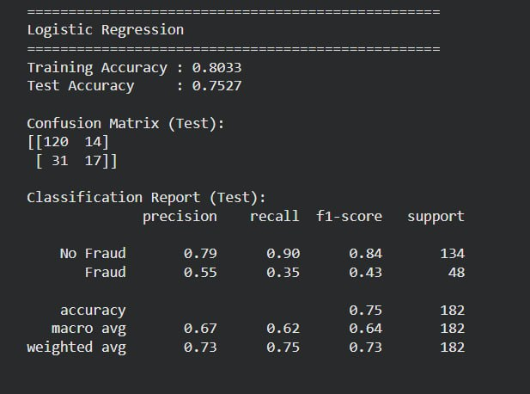

5. Naïve Bayes Model
5.1 Overview
Naïve Bayes is a family of probabilistic classifiers based on Bayes' theorem with a strong (naïve) independence assumption between features. Despite its simplicity, it often performs surprisingly well, especially for text classification and other high-dimensional problems.
5.2 Bayes' Theorem
For a given instance with feature vector $X=(x_{1},x_{2},...,x_{n})$, the probability of class $C_{k}$ is:
$$P(C_{k}∣X)=\frac{P(X∣C_{k})P(C_{k})}{P(X)}$$
where:
- $P(C_{k})$ is the prior probability of class $k$.
- $P(X∣C_{k})$ is the likelihood of observing $X$ given class $k$.
- $P(X)$ is the evidence (normalizing constant).
5.3 Naïve Independence Assumption
The algorithm assumes that features are conditionally independent given the class. Thus:
$$P(X∣C_{k})=\prod_{i=1}^{n}{P(}x_{i}∣C_{k})$$
This simplifies estimation, as we only need to compute the probability of each feature separately per class.
5.4 Types of Naïve Bayes
Depending on the nature of features, different distributions are assumed:
- Gaussian Naïve Bayes: Assumes continuous features follow a normal distribution. The likelihood is computed using the mean and variance of each feature per class. This is appropriate for features like age, claim amount, etc.
- Multinomial Naïve Bayes: Used for discrete counts (e.g., word counts in text).
- Bernoulli Naïve Bayes: For binary features.
In this project, Gaussian Naïve Bayes is applied because the features (after scaling) are continuous.
5.5 Training and Prediction
- Training: For each class, compute the prior $P(C_{k})$ (based on class frequencies). For each feature, estimate the parameters of its assumed distribution (mean and standard deviation for Gaussian) from the training data.
- Prediction: For a new instance, compute the posterior probability for each class using Bayes' theorem (the denominator $P(X)$ is constant across classes, so it can be ignored for comparison). The class with the highest posterior is chosen.
5.6 Advantages
- Very fast to train and predict.
- Handles high-dimensional data well.
- Performs well with small datasets.
- Provides probabilistic predictions.
- Robust to irrelevant features (though independence assumption may be violated).
5.7 Disadvantages
- The independence assumption is often unrealistic in real-world data, potentially harming performance when features are correlated.
- Zero probability problem: If a feature value never appears in the training set for a given class, the likelihood becomes zero, wiping out all information. Smoothing techniques (e.g., Laplace smoothing) mitigate this, but for Gaussian NB, this is less of an issue.
5.8 Application in Fraud Detection
Naïve Bayes can serve as a quick, interpretable baseline. However, because features in insurance data (e.g., claim amounts) are often correlated, its performance may be lower than models that account for dependencies.
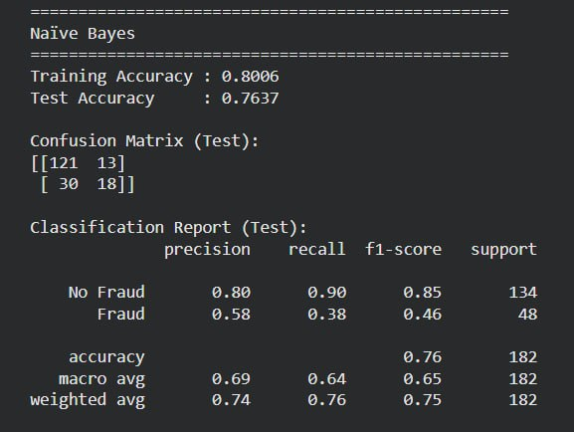

6. Support Vector Machine (SVM) Model
6.1 Overview
Support Vector Machine is a powerful supervised learning algorithm for classification and regression. In binary classification, it finds the optimal hyperplane that maximizes the margin between the two classes. SVM can handle both linear and non-linear boundaries through the kernel trick.
6.2 Linear SVM
- Hyperplane: A decision boundary defined by $w⋅x+b=0$, where $w$ is the weight vector and $b$ is the bias.
- Margin: The distance from the hyperplane to the nearest data points of each class (support vectors). SVM aims to maximize this margin, which leads to better generalization.
- Optimization: The objective is to minimize $∥w∥^{2}$ subject to the constraint that all points are correctly classified with a margin of at least 1 (for separable data). This is a convex optimization problem.
6.3 Soft Margin and Regularization
In practice, data may not be perfectly separable. The soft margin SVM introduces slack variables $ξ_{i}$ that allow some points to be misclassified or lie within the margin. The trade-off between margin width and misclassification is controlled by parameter $C$:
- Small $C$: larger margin, but may misclassify more points (high bias, low variance).
- Large $C$: smaller margin, tries to classify all points correctly (low bias, high variance).
6.4 Kernel Trick
To handle non-linear boundaries, SVM can map the input features into a higher-dimensional space using a kernel function, without explicitly computing the transformation. Common kernels include:
- Linear Kernel: $K(x,x^{'})=x⋅x^{'}$ – equivalent to linear SVM.
- Polynomial Kernel: $K(x,x^{'})=(γx⋅x^{'}+r)^{d}$.
- Radial Basis Function (RBF) Kernel: $K(x,x^{'})=exp⁡(-γ∥x-x^{'}∥^{2})$. This is a popular choice because it can model complex, non-linear relationships. The parameter $γ$ controls the influence of a single training example (low gamma → smooth decision boundary, high gamma → more complex).
6.5 Training and Prediction
- Training: The algorithm solves a quadratic programming problem to find the support vectors and the optimal hyperplane. Only support vectors affect the decision boundary.
- Prediction: For a new point, the decision function is based on the sign of $∑α_{i}y_{i}K(x_{i},x)+b$, where $α_{i}$ are Lagrange multipliers from training.
6.6 Advantages
- Effective in high-dimensional spaces.
- Memory efficient because only support vectors are stored.
- Versatile due to kernel trick; can model complex boundaries.
- Robust to overfitting, especially in high dimensions.
6.7 Disadvantages
- Training can be slow for large datasets.
- Choice of kernel and hyperparameters ($C$, $γ$) is critical and often requires grid search.
- Black-box nature: less interpretable than linear models.
- Sensitive to feature scaling (hence scaling is crucial).
6.8 Application in Fraud Detection
SVM can be very effective in fraud detection when the data is not too large and the decision boundary is complex. With an RBF kernel, it can capture intricate patterns that separate fraudulent from legitimate claims. However, hyperparameter tuning is essential to avoid overfitting or underfitting.
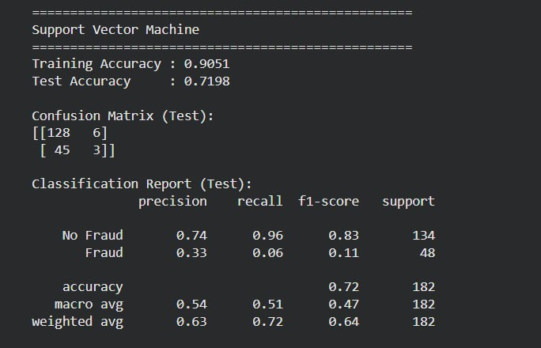

7. Testing the Model
7.1 Purpose of Model Testing
After training models on the training set, it is essential to evaluate their performance on unseen data to assess generalization. This is done using the test set, which was held out during training. Testing provides an unbiased estimate of how the model will perform in production.
7.2 Evaluation Metrics
For binary classification, several metrics are derived from the confusion matrix, which tabulates:
- True Positives (TP): Fraudulent claims correctly identified.
- True Negatives (TN): Non-fraudulent claims correctly identified.
- False Positives (FP): Non-fraudulent claims incorrectly flagged as fraud (Type I error).
- False Negatives (FN): Fraudulent claims missed (Type II error).
a. Accuracy
$$Accuracy=\frac{TP+TN}{TP+TN+FP+FN}$$
Accuracy measures overall correctness but can be misleading when classes are imbalanced (e.g., if only 10% are fraud, a model that predicts "non-fraud" for all achieves 90% accuracy).
b. Precision
$$Precision=\frac{TP}{TP+FP}$$
Precision answers: Of all claims predicted as fraud, how many were actually fraud? High precision means low false positives, which is important if falsely accusing a customer has high cost.
c. Recall (Sensitivity)
$$Recall=\frac{TP}{TP+FN}$$
Recall answers: Of all actual fraud cases, how many did we catch? High recall means few frauds are missed, which is critical if missing fraud has high financial impact.
d. F1-Score
$$F1=2×\frac{Precision×Recall}{Precision+Recall}$$
The F1-score is the harmonic mean of precision and recall, providing a single metric that balances both. It is especially useful for imbalanced datasets.
e. Classification Report
A classification report summarizes precision, recall, and F1-score for each class, along with support (number of instances). This gives a comprehensive view of model performance per class.
7.3 Confusion Matrix Visualization
The confusion matrix is often displayed as a heatmap to visually compare predicted vs. actual labels. It helps identify which classes are frequently misclassified.
7.4 Importance of Class Imbalance
In fraud detection, the dataset is typically imbalanced (few fraud cases). Accuracy alone is insufficient; models must be evaluated using precision, recall, and F1-score. A model with high recall but low precision might flag too many false alarms, while high precision but low recall misses many frauds. The choice of metric depends on business priorities: minimizing financial loss (recall) vs. minimizing customer annoyance (precision).
7.5 Cross-Validation
Although not part of "testing" per se, cross-validation (e.g., k-fold) is often used during model selection to tune hyperparameters and get a more robust estimate of performance. In this project, cross-validation is applied after initial model building to compare models and before hyperparameter tuning.
7.6 Model Comparison
After evaluating all models on the test set, their test accuracies (and other metrics) are compared. The model with the highest test accuracy (or best trade-off based on business needs) is selected as the final model. However, it is crucial to also consider cross-validation scores to ensure the result is not due to a lucky test split.
7.7 Hyperparameter Tuning and Final Evaluation
To further improve performance, hyperparameter tuning (e.g., GridSearchCV) is performed on the best candidate model(s). The tuning process uses cross-validation on the training set to find optimal parameters. The final tuned model is then evaluated on the test set to obtain an unbiased estimate of its performance. This final test accuracy is recorded as the true generalization ability.
